Contents of ERD Flow
- Identity & Organization ERD
- Compliance Assessment Workflow ERD
- Reporting & Evidence ERD
- Optional Billing / Subscription ERD
- Recommended implementation notes

1) Identity & Organization ERD
This covers:
- multi-tenant organization model
- users
- roles
- permissions
- groups / hierarchical access
- Memberships
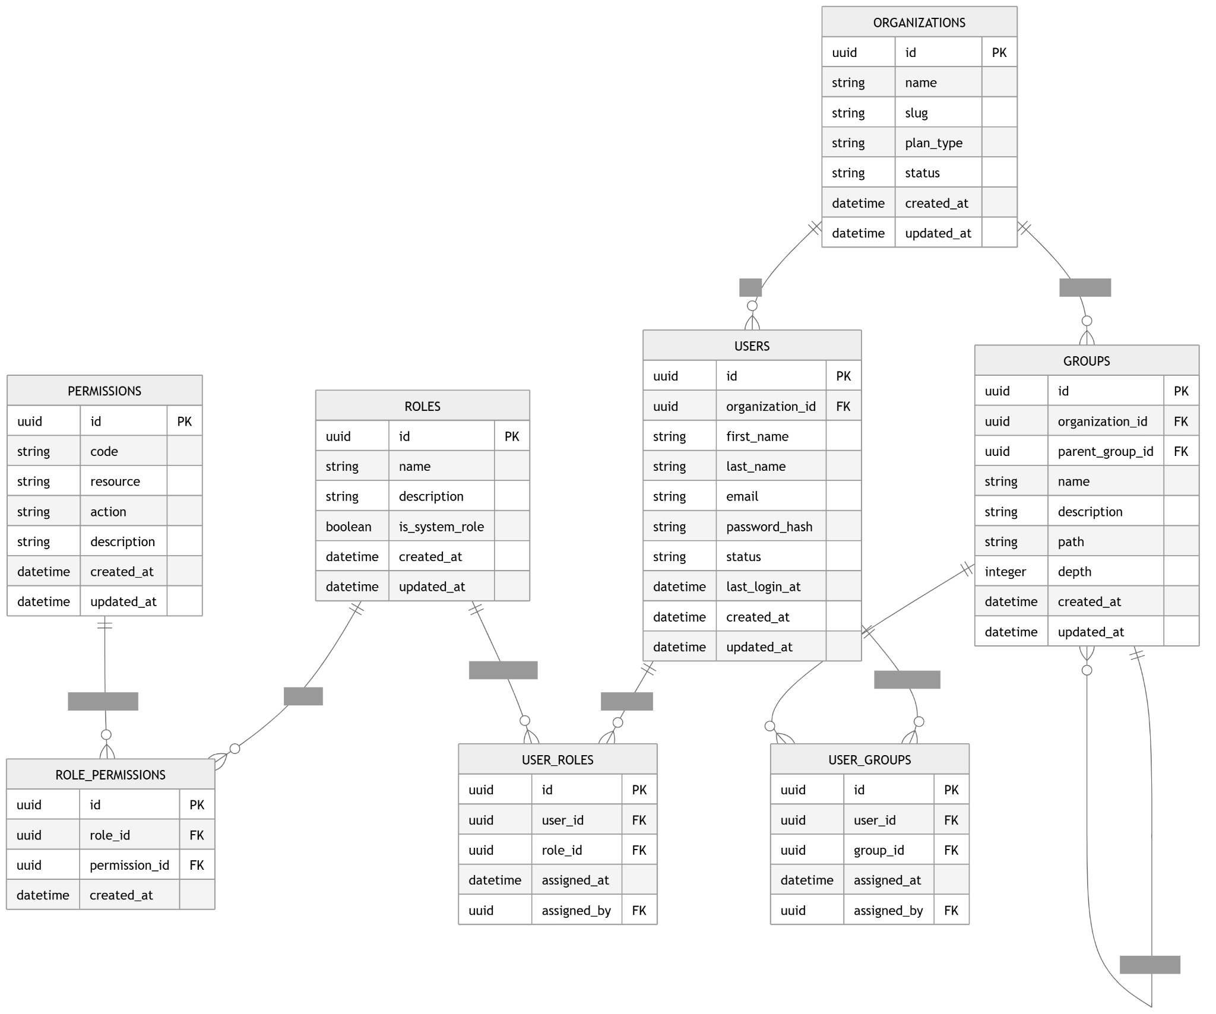
erDiagram

ORGANIZATIONS {
uuid id PK
string name
string slug
string industry
string organization_type
string status
string subscription_plan
datetime created_at
datetime updated_at
}

USERS {
uuid id PK
string first_name
string last_name
string email UK
string password_hash
string job_title
string status
datetime last_login_at
datetime created_at
datetime updated_at
}

ROLES {
uuid id PK
string name UK
string description
boolean is_system_role
datetime created_at
datetime updated_at
}

PERMISSIONS {
uuid id PK
string resource
string action
string permission_key UK
string description
datetime created_at
datetime updated_at
}

ROLE_PERMISSIONS {
uuid id PK
uuid role_id FK
uuid permission_id FK
datetime created_at
}

ORGANIZATION_MEMBERSHIPS {
uuid id PK
uuid organization_id FK
uuid user_id FK
uuid role_id FK
string membership_status
datetime invited_at
datetime joined_at
datetime created_at
datetime updated_at
}

GROUPS {
uuid id PK
uuid organization_id FK
uuid parent_group_id FK
string name
string description
string group_type
datetime created_at
datetime updated_at
}

GROUP_MEMBERSHIPS {
uuid id PK
uuid group_id FK
uuid user_id FK
string membership_type
datetime created_at
}

ORGANIZATIONS ||--o{ ORGANIZATION_MEMBERSHIPS : has
USERS ||--o{ ORGANIZATION_MEMBERSHIPS : belongs_to
ROLES ||--o{ ORGANIZATION_MEMBERSHIPS : assigned_as

ROLES ||--o{ ROLE_PERMISSIONS : grants
PERMISSIONS ||--o{ ROLE_PERMISSIONS : included_in

ORGANIZATIONS ||--o{ GROUPS : contains
GROUPS ||--o{ GROUPS : parent_of
GROUPS ||--o{ GROUP_MEMBERSHIPS : has
USERS ||--o{ GROUP_MEMBERSHIPS : joins

Interpretation
This model gives you:
- one user account per person
- One organization membership for MVP
- hard-coded roles for MVP, extensible later
- group-based access control for departments, teams, or business units
- future-ready permission system without needing dynamic role editing on day one
2) Compliance Assessment Workflow ERD
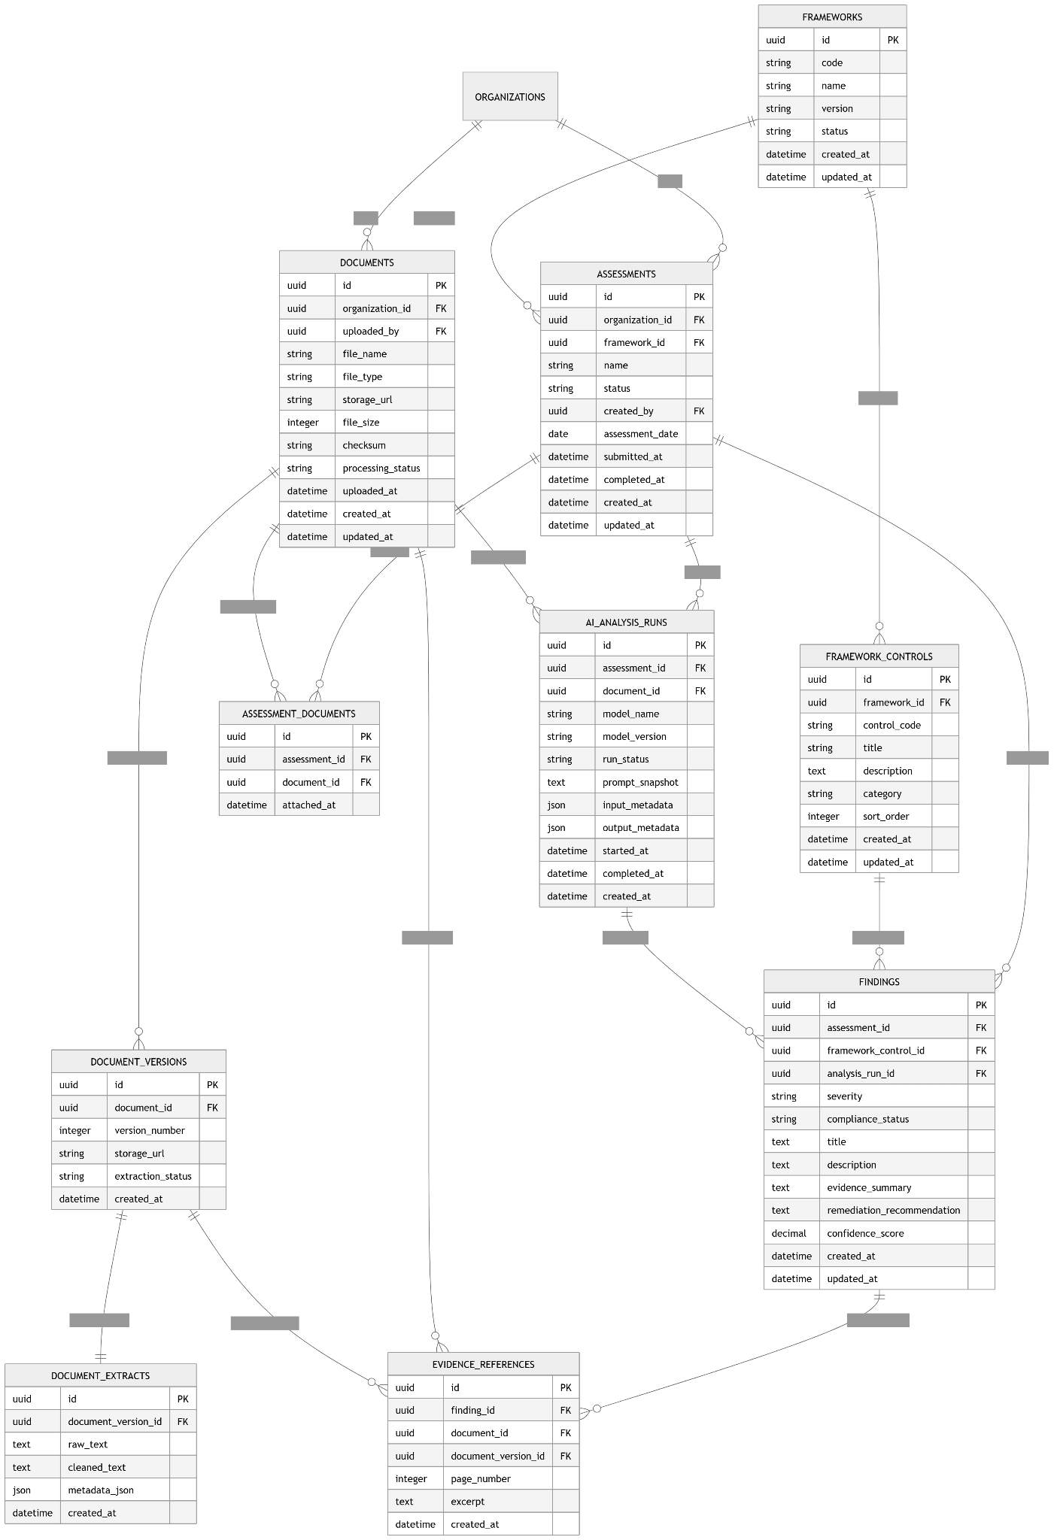
This is the heart of Evolve Edge.
It covers:
- frameworks
- controls
- assessments
- uploaded documents
- AI analysis runs
- findings/gaps
- remediation tasks
erDiagram

ORGANIZATIONS {
uuid id PK
string name
}

FRAMEWORKS {
uuid id PK
string code UK
string name
string version
string category
boolean is_active
datetime created_at
datetime updated_at
}

FRAMEWORK_CONTROLS {
uuid id PK
uuid framework_id FK
string control_code
string title
text description
string severity_default
string domain
boolean is_required
integer sort_order
datetime created_at
datetime updated_at
}

ASSESSMENTS {
uuid id PK
uuid organization_id FK
uuid framework_id FK
string name
string status
date assessment_date
uuid created_by FK
uuid assigned_to FK
datetime started_at
datetime completed_at
datetime created_at
datetime updated_at
}

DOCUMENTS {
uuid id PK
uuid organization_id FK
uuid uploaded_by FK
string file_name
string file_type
string storage_path
integer file_size_bytes
string checksum
string classification
string parse_status
datetime uploaded_at
datetime created_at
datetime updated_at
}

ASSESSMENT_DOCUMENTS {
uuid id PK
uuid assessment_id FK
uuid document_id FK
datetime created_at
}

DOCUMENT_EXTRACTS {
uuid id PK
uuid document_id FK
text extracted_text
string extraction_status
string parser_version
datetime created_at
datetime updated_at
}

AI_ANALYSIS_RUNS {
uuid id PK
uuid assessment_id FK
uuid document_id FK
string model_name
string model_version
string run_status
text prompt_template_version
decimal confidence_score
datetime started_at
datetime completed_at
datetime created_at
datetime updated_at
}

FINDINGS {
uuid id PK
uuid assessment_id FK
uuid framework_control_id FK
uuid ai_analysis_run_id FK
string title
text description
string finding_type
string severity
string compliance_status
decimal confidence_score
text rationale
datetime created_at
datetime updated_at
}

REMEDIATION_TASKS {
uuid id PK
uuid finding_id FK
uuid assigned_to FK
string title
text description
string status
string priority
date due_date
datetime completed_at
datetime created_at
datetime updated_at
}

ORGANIZATIONS ||--o{ ASSESSMENTS : owns
FRAMEWORKS ||--o{ FRAMEWORK_CONTROLS : contains
ORGANIZATIONS ||--o{ DOCUMENTS : uploads
ASSESSMENTS ||--o{ ASSESSMENT_DOCUMENTS : uses
DOCUMENTS ||--o{ ASSESSMENT_DOCUMENTS : attached_to
DOCUMENTS ||--|| DOCUMENT_EXTRACTS : parsed_into

ASSESSMENTS ||--o{ AI_ANALYSIS_RUNS : triggers
DOCUMENTS ||--o{ AI_ANALYSIS_RUNS : analyzed_in

ASSESSMENTS ||--o{ FINDINGS : produces
FRAMEWORK_CONTROLS ||--o{ FINDINGS : maps_to
AI_ANALYSIS_RUNS ||--o{ FINDINGS : generated

FINDINGS ||--o{ REMEDIATION_TASKS : creates

Interpretation
This is the MVP engine:
- The organization starts an assessment
- selects a framework
- uploads documents
- documents are parsed
- AI analyzes document text against framework controls
- findings are created
- Remediation tasks can be assigned

3) Reporting & Evidence ERD
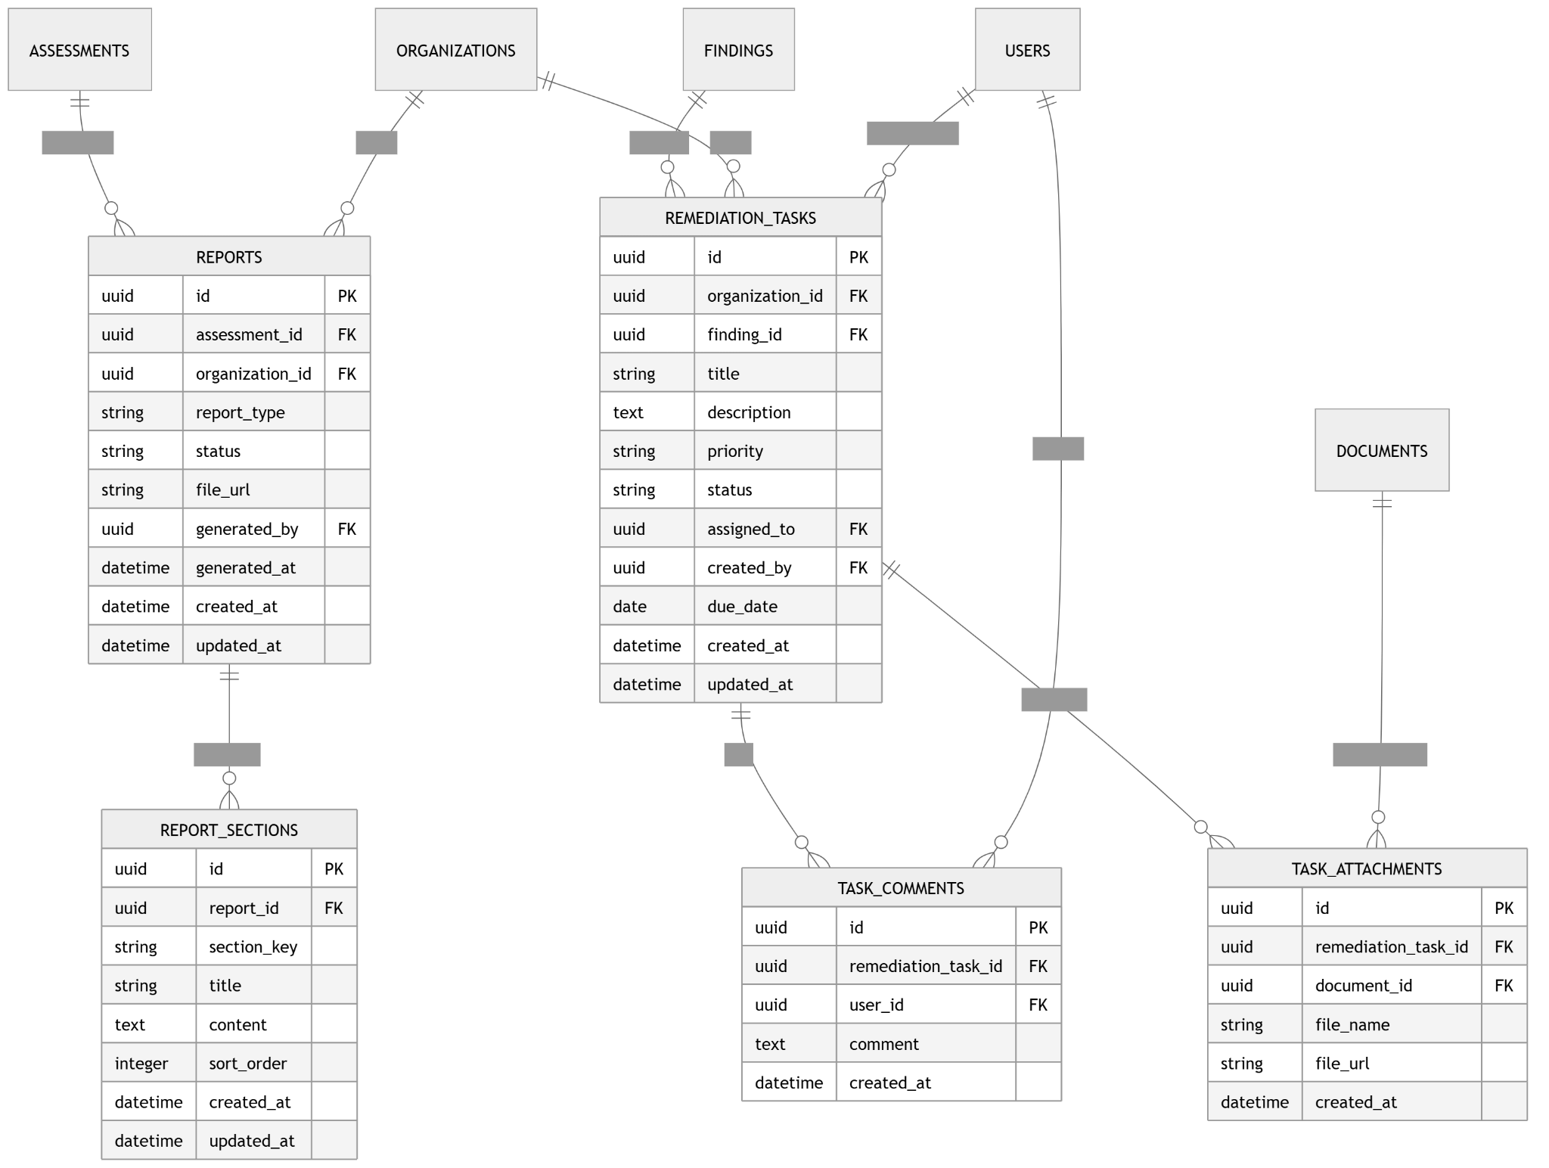
This supports:
- audit trails
- evidence mapping
- final reports
- report exports
- explainability
erDiagram

ASSESSMENTS {
uuid id PK
string name
string status
datetime created_at
}

FINDINGS {
uuid id PK
uuid assessment_id FK
uuid framework_control_id FK
string title
string severity
string compliance_status
text rationale
datetime created_at
datetime updated_at
}

DOCUMENTS {
uuid id PK
string file_name
string file_type
datetime uploaded_at
}

EVIDENCE_REFERENCES {
uuid id PK
uuid finding_id FK
uuid document_id FK
integer page_number
text excerpt
string citation_label
decimal relevance_score
datetime created_at
}

REPORTS {
uuid id PK
uuid assessment_id FK
string report_type
string status
string version
uuid generated_by FK
datetime generated_at
datetime created_at
datetime updated_at
}

REPORT_SECTIONS {
uuid id PK
uuid report_id FK
string section_key
string title
text content
integer sort_order
datetime created_at
datetime updated_at
}

REPORT_FINDINGS {
uuid id PK
uuid report_id FK
uuid finding_id FK
integer sort_order
datetime created_at
}

EXPORTS {
uuid id PK
uuid report_id FK
string export_format
string file_path
string export_status
datetime exported_at
datetime created_at
}

AUDIT_LOGS {
uuid id PK
uuid organization_id FK
uuid user_id FK
string entity_type
uuid entity_id
string action
json metadata
datetime created_at
}

ASSESSMENTS ||--o{ FINDINGS : has
FINDINGS ||--o{ EVIDENCE_REFERENCES : supported_by
DOCUMENTS ||--o{ EVIDENCE_REFERENCES : cited_in

ASSESSMENTS ||--o{ REPORTS : generates
REPORTS ||--o{ REPORT_SECTIONS : contains
REPORTS ||--o{ REPORT_FINDINGS : includes
FINDINGS ||--o{ REPORT_FINDINGS : appears_in
REPORTS ||--o{ EXPORTS : exported_as

Interpretation
This allows Evolve Edge to produce:
- executive summary reports
- technical compliance reports
- evidence-backed findings
- downloadable PDF/CSV/DOCX exports later
- traceability for audits and client trust

4) Billing / Subscription ERD
SaaS readiness.
erDiagram

ORGANIZATIONS {
uuid id PK
string name
string status
datetime created_at
}

SUBSCRIPTION_PLANS {
uuid id PK
string name
string billing_interval
integer price_cents
integer assessment_limit
integer user_limit
integer storage_limit_mb
boolean is_active
datetime created_at
datetime updated_at
}

SUBSCRIPTIONS {
uuid id PK
uuid organization_id FK
uuid subscription_plan_id FK
string provider
string provider_customer_id
string provider_subscription_id
string status
date current_period_start
date current_period_end
boolean cancel_at_period_end
datetime created_at
datetime updated_at
}

INVOICES {
uuid id PK
uuid subscription_id FK
string provider_invoice_id
integer amount_cents
string currency
string status
datetime issued_at
datetime paid_at
datetime created_at
}

ORGANIZATIONS ||--o| SUBSCRIPTIONS : has
SUBSCRIPTION_PLANS ||--o{ SUBSCRIPTIONS : assigned_to
SUBSCRIPTIONS ||--o{ INVOICES : produces

5) MVP Table Set
Minimum viable production schema should include these tables first:

Required for MVP
- organizations
- users
- roles
- permissions
- role_permissions
- organization_memberships
- groups
- group_memberships
- frameworks
- framework_controls
- assessments
- documents
- assessment_documents
- document_extracts
- ai_analysis_runs
- findings
- remediation_tasks
- evidence_references
- reports
- report_sections
- audit_logs
- subscriptions
- subscription_plans
- invoices
- report_findings
- exports

6) Relationships Summary
For Evolve Edge, the most important relationship rules are:
- A user belongs to an organization through organization_memberships
- An organization can have many groups
- A group can have a parent group for hierarchy
- A framework has many controls
- An organization can run many assessments
- An assessment belongs to one framework
- An assessment can analyze many documents
- A document can be reused across assessments if desired
- An AI analysis run links a document to a specific assessment run
- A finding should map to:
  - one assessment
  - one control
  - optionally, one AI analysis run
- A finding can have many evidence references
- A report belongs to one assessment

7) Implementation Notes

Hard-code roles in MVP
Use seeded roles like:
- super_admin
- org_admin
- compliance_manager
- analyst
- viewer

Keep permissions normalized
Even if roles are hard-coded, store permissions in tables now so later expansion is easier.

Separate document storage from extracted text
Store file metadata in documents, but extracted content in document_extracts.

Do not store AI output only as raw blobs
Convert analysis into structured entities:
- findings
- evidence references
- risk scores
- remediation tasks

Make findings control-centric
A finding should always link back to a control whenever possible. That makes framework reporting much easier.

Audit logging is not optional
Because this is compliance/security software, log:
- document upload
- assessment creation
- AI run execution
- finding overrides
- report generation
- user role changes

8) “Master ERD” for MVP
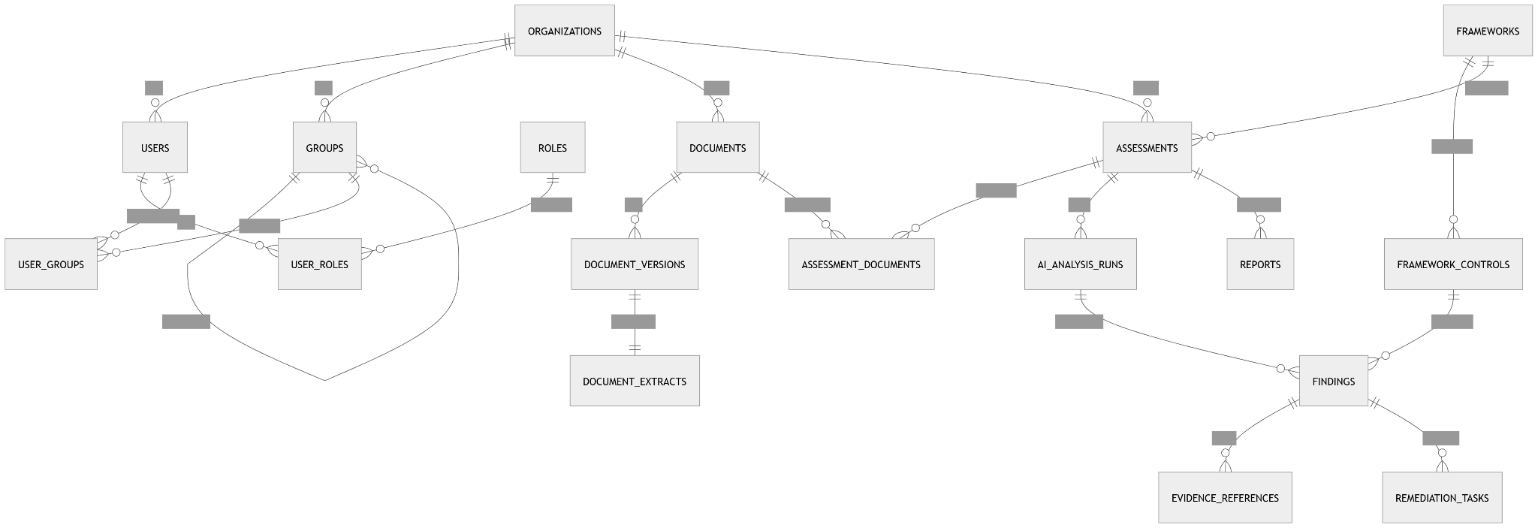
one consolidated ERD to use first
erDiagram

ORGANIZATIONS ||--o{ ORGANIZATION_MEMBERSHIPS : has
USERS ||--o{ ORGANIZATION_MEMBERSHIPS : belongs_to
ROLES ||--o{ ORGANIZATION_MEMBERSHIPS : assigned_as

ROLES ||--o{ ROLE_PERMISSIONS : grants
PERMISSIONS ||--o{ ROLE_PERMISSIONS : contains

ORGANIZATIONS ||--o{ GROUPS : contains
GROUPS ||--o{ GROUPS : parent_of
GROUPS ||--o{ GROUP_MEMBERSHIPS : has
USERS ||--o{ GROUP_MEMBERSHIPS : joins

ORGANIZATIONS ||--o{ ASSESSMENTS : owns
FRAMEWORKS ||--o{ FRAMEWORK_CONTROLS : includes
ASSESSMENTS }o--|| FRAMEWORKS : uses

ORGANIZATIONS ||--o{ DOCUMENTS : owns
ASSESSMENTS ||--o{ ASSESSMENT_DOCUMENTS : contains
DOCUMENTS ||--o{ ASSESSMENT_DOCUMENTS : attached_to
DOCUMENTS ||--|| DOCUMENT_EXTRACTS : parsed_to

ASSESSMENTS ||--o{ AI_ANALYSIS_RUNS : executes
DOCUMENTS ||--o{ AI_ANALYSIS_RUNS : analyzed_in

ASSESSMENTS ||--o{ FINDINGS : produces
FRAMEWORK_CONTROLS ||--o{ FINDINGS : mapped_to
AI_ANALYSIS_RUNS ||--o{ FINDINGS : generates

FINDINGS ||--o{ EVIDENCE_REFERENCES : supported_by
DOCUMENTS ||--o{ EVIDENCE_REFERENCES : sourced_from

FINDINGS ||--o{ REMEDIATION_TASKS : creates

ASSESSMENTS ||--o{ REPORTS : generates
REPORTS ||--o{ REPORT_SECTIONS : contains
REPORTS ||--o{ EXPORTS : exported_as

ORGANIZATIONS ||--o{ AUDIT_LOGS : records
USERS ||--o{ AUDIT_LOGS : performs

9) ERD Package:
- ERD 1: Identity + Tenant Access
- ERD 2: Assessment + AI Analysis
- ERD 3: Evidence + Reporting
- ERD 4: Billing

